**2024.07.28**

**Engineering Question of PN:QANTUM_PROJECT**

**Question 1:** See below IMG, just offered the stackup and the surface treatment and soldmask/legend color are not specified.

**Suggestion:** Use black solder mask/white legend and Immersion Gold to do.

**Reply: yes**

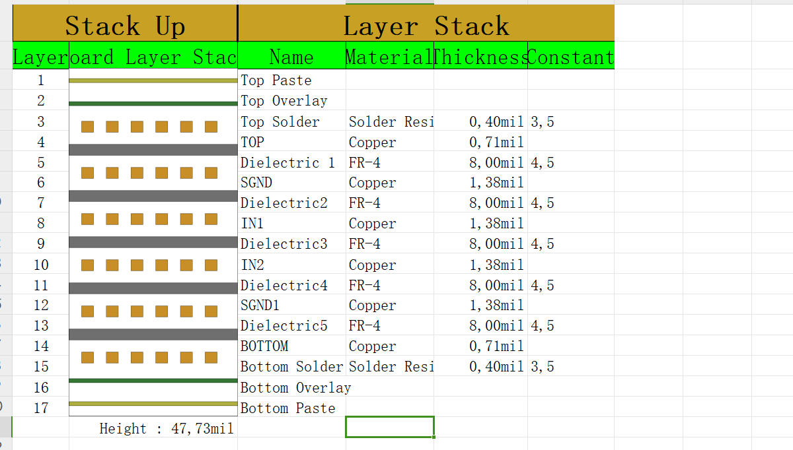

**Question 2:** See below IMG, we don’t know the usage of GKO, GM11 and GM7 layer.

**Suggestion 1:** Ignore them

**Suggestion 2:** Or please indicated.

**Reply: Ignore**

**PIC2:**

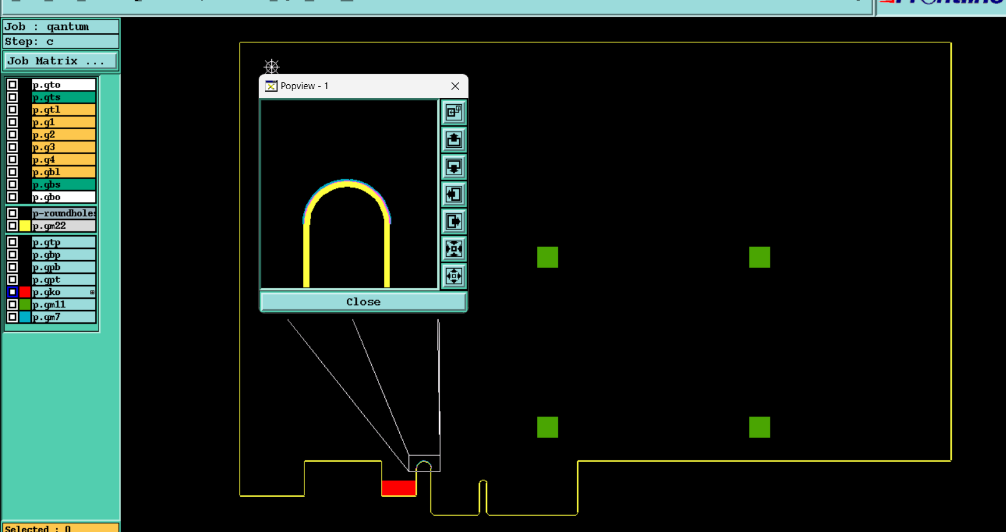

**Question 3:** See below IMG, customer didn’t mention the gold thickness of fingers pads.

**Suggestion:** We will plated hard gold with 10u” to build.

**Reply: Yes**

**PIC3:**

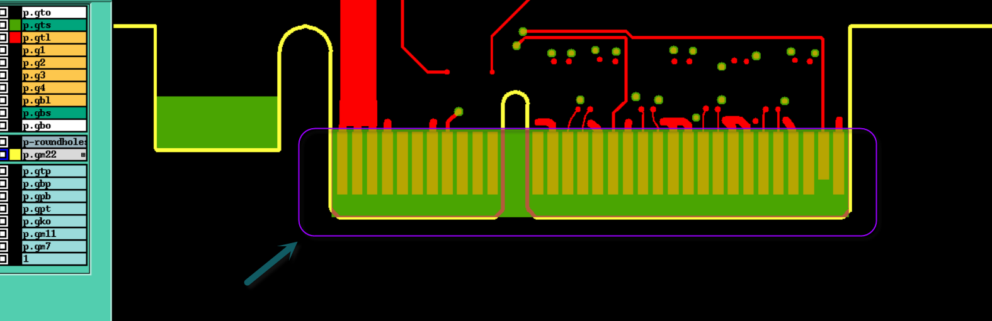

**Question 4:** About the fingers pads, we will chamfer(Bevel) as our normally to build, please confirm

**Suggestion:** Please confirm

**Reply: Yes**

**PIC4:**



**Question 5:** See below IMG, there are some solder mask opening of via holes very closed to the fingers, it will be affected plated gold. (those cu pads of via holes may can’t be done with gold)

**Suggestion:** Delete those 7X soldmask opening of via holes on both sides and covered with soldmask ink.

**Reply: we agree to remove it if it interferes with the application of gold**

**PIC5:**

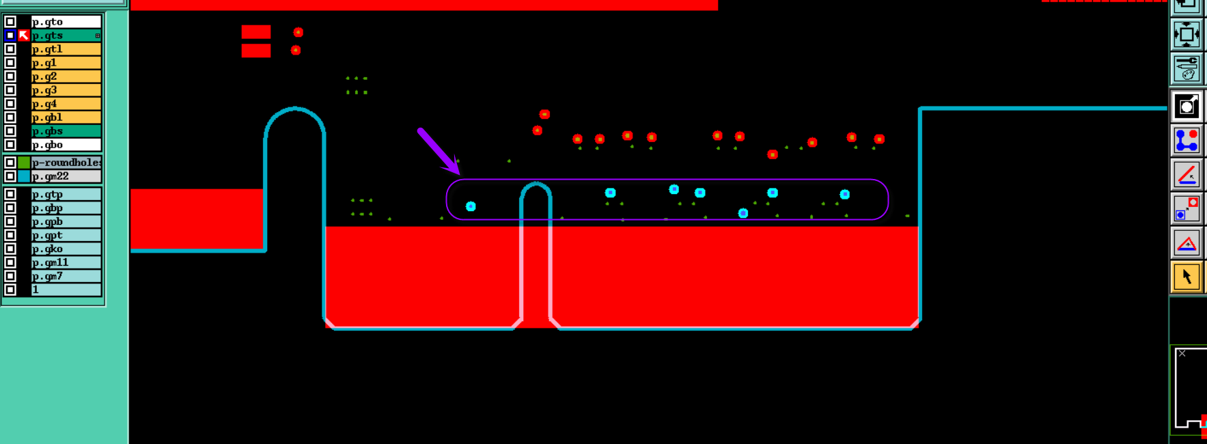

**Question 6:** See below IMG, there are six non-plated holes located on the Cu pad, we are not sure it is normal design or not.

**Suggestion 1:** Change them to PTH.

**Suggestion 2:** Make them as NPTH, but we need to cut the cu pad to get 0.2mm gap from holes edge to avoid copper exposed

**Reply: Suggestion 2**

**PIC6:**

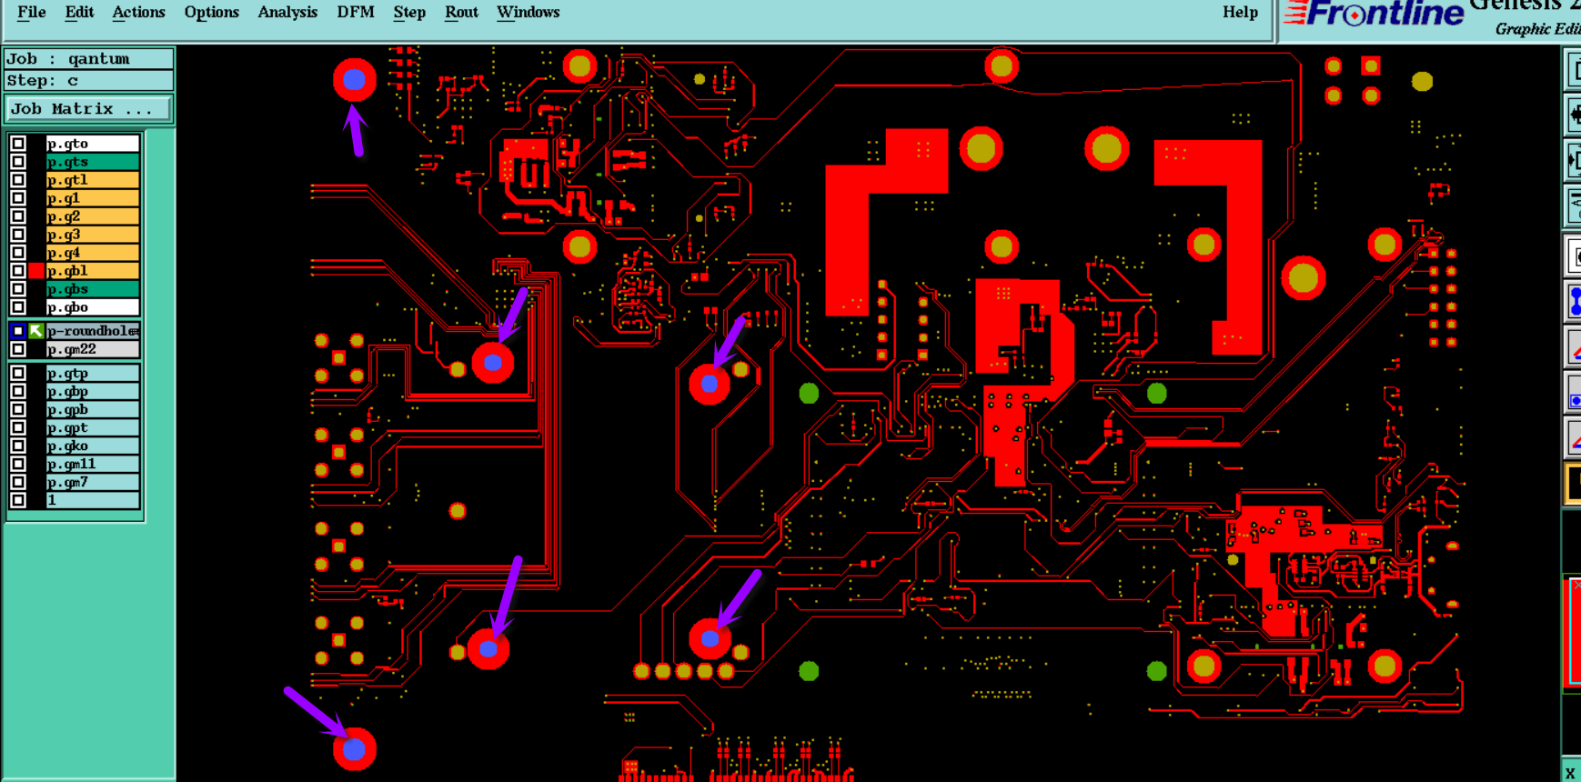

**Question 7:** See below IMG for example, there are designed with soldmask opening on some via holes. It will be easy cause shorten in solder process.Can we delete the soldmask opening of via holes and covered with soldmask ink？

**Suggestion 1:** Allow to delete the soldmask opening of all Dia0.2mm and Dia0.25mm and covered with sodlamsk ink.

**Suggestion 2:** Follow the original gerber files.

**Reply: Suggestion 2**

**PIC7:**

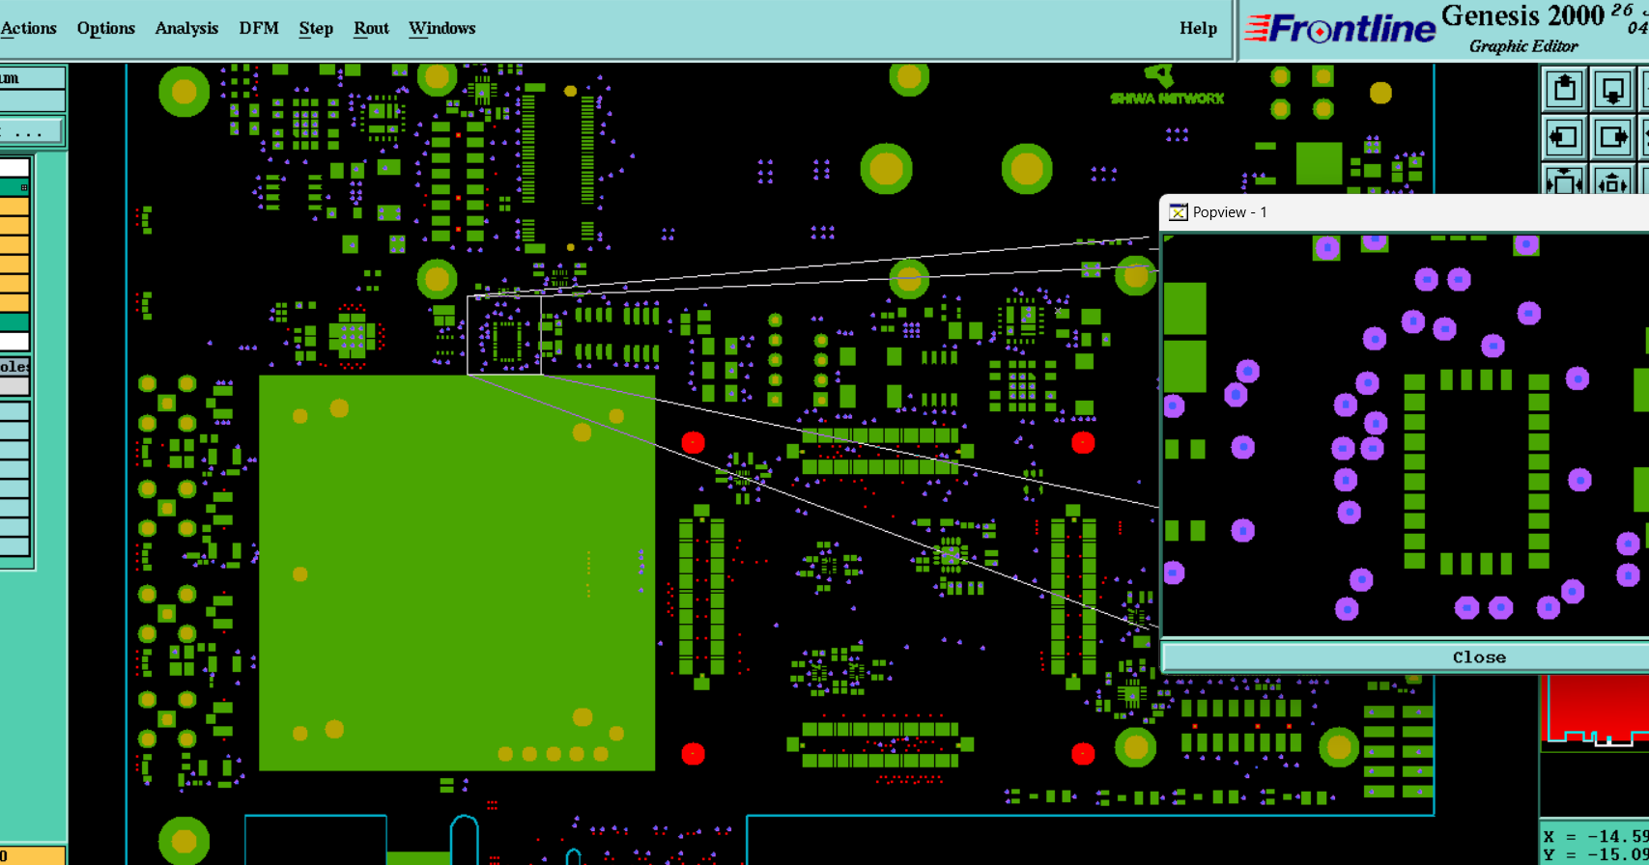

**Question 8:** See below IMG, some via holes located on the SMD pads, it will be affected solder.

**Suggestion:** All Dia0.2mm and Dia0.25mm via holes will be plugged with epoxy resin and capped with copper.

**Reply: yes**

**PIC8:**

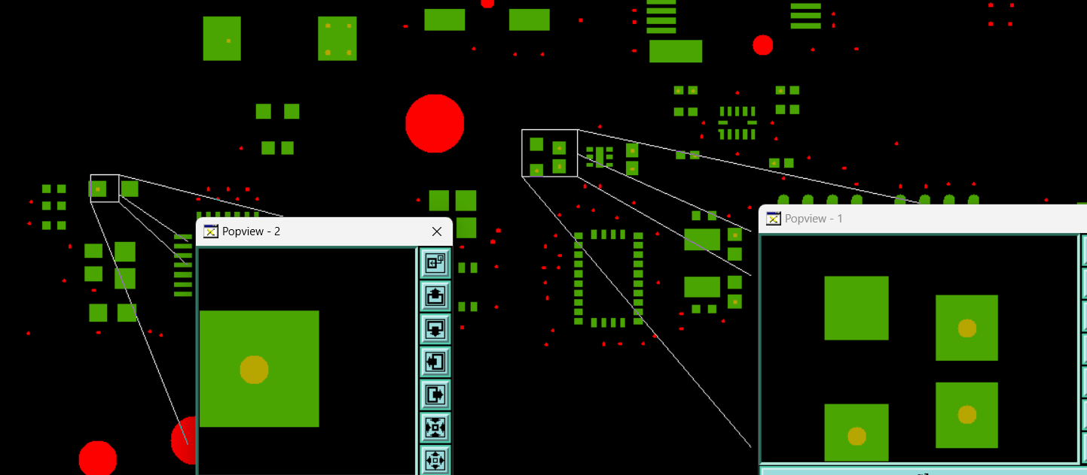

**Question 9:** See below IMG for example, some legend texts located on the Cu pads and no enough rooms to move.

**Suggestion:** Allow to shave them, and accept those legend texts fuzzy and incomplete.

**Reply: Yes**

**PIC9:**

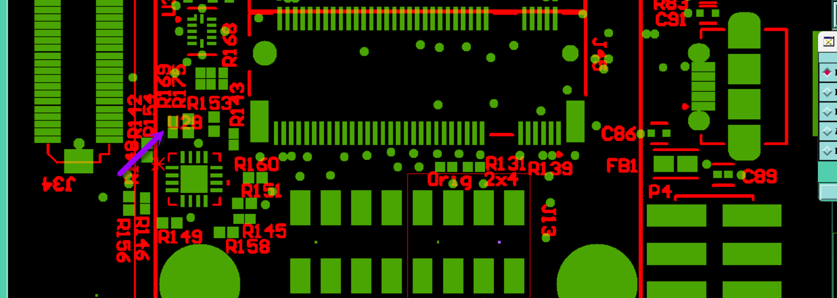

**Question 10:** See below IMG, the barcode too small to build, it will be fuzzy and can’t be recognize

**Suggestion 1:** Accept the fuzzy and unrecognize of the barcode.

**Suggestion 2:** Follow

**Reply: Suggestion 1**

**PIC10:**

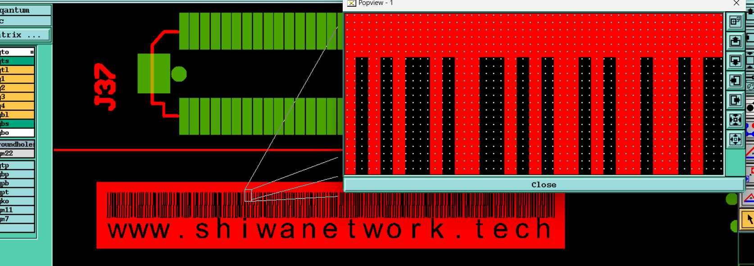

**Question 11:** See below IMG, to traceability, we will add datecode (wwyy) and silkscreen block(To laser engraving label (Include serial number info after assembly)) the top silkscreen layer, please confirm

**Suggestion:** Please confirm

**Reply: Yes**

**PIC11:**

